

Take Home Project

Design a harness for a tutorial (any physics) of your choice

Time: 4-5 hours. Format: we anticipate a design document and a working demo

Context
We support companies building serious physical products (fusion reactors, surgical robots, humanoids, aircraft). Designing them efficiently from CAD to post processing takes an important level of automation, which is the purpose of this real-life exercise.
Your Task:
You will be asked to create an automated simulation workflow, taking a well understood (and manual) simulation process, and automating the tasks necessary to complete it using AI. We recommend building an agent-driven process with an LLM having the ability to plan actions, call tools, perform tasks and evaluate results in a stage-gated manner.
We recommend choosing a physical simulation environment that you are most familiar with. Previous candidates have built environments for robotics, aero, thermal and electromagnetic simulations. For example, if you choose CFD (e.g. openFOAM), we would recommend performing the following steps:
- create a 2D bespoke wing profile (e.g. NACA) of your choice to be used for a CFD simulation of the airflow around the wing. OpenFOAM opensource software will be used for the simulation. You can use any CAD software or equivalent;

- In this CFD case, you may find a tutorial from the OpenFOAM Tutorial Guide helpful, e.g. flow around a cylinder (see snapshot on Figure 1). The simple tutorial can be studied then run.
Note that you may have to create a development account to download the necessary software;
- Once familiar with OpenFOAM, you are ready for the main task. We want you to build a primitive AI engineer. We want you to create a agent that can run closed loop iteration cycle. Starting from a wing-profile, build an AI agent (harness etc) that can control all steps in the loop, from creating a mesh from the input geometry, setting up the simulation, running the simulation and post processing the results. A good process will enable automatic moving between workflow steps via gates where the AI can plan out actions and perform tasks.
- A great process shows a clear customer journey inherent in the workflow. Thought should be given as to how the human engineer should interface with the workflow - what can they now achieve with the workflow that they otherwise could not, or extend to build better hardware, faster.
- Be ready to demo and discuss your experience (20 minutes).

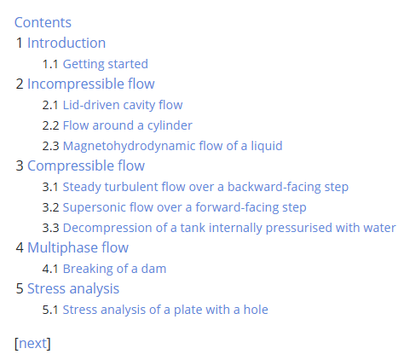
Figure 1: list of tutorials
Deliverables:

- a design document, a code base, and a full live demo

